**Fruits/Vegetables Segregation System**

**Automation of the Segregation process (easing the human efforts in sorting food items)**

Conveyer Belt diversion using rotating disk on the basis on which item is detected by the camera.

Uses Computer Vision for the detection and AI to distinguish between the items. The program sends a signal to the actuator that instantaneously rotates and deviates the path of the item.

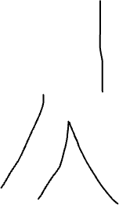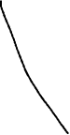

Servo motor (or any other worthy alternative) to rotate the segregating disk.

The process of segregation of materials involves heavy workforce and demands a lot of human efforts. It gets exhausting and strenuous as the speed of the conveyer belt is high and the segregation process requires agility and concentration if we expect an efficient and accurate sorting of materials. Being a human, it is not possible for us to work tirelessly without a proper amount of rest.

This is where a machine, specifically a machine powered by Artificial Intelligence come handy. A machine doesn’t require any rest and so this makes it perfect for the job.